16.September 2025

Kliimaministeerium

Pöördumine

Eesti maakasutussektor seisab käesoleval aastal silmitsi erakordselt keeruliste ilmastikuoludega, mis on oluliselt takistanud põllumajandustootjate ja maaomanike tavapärast tegevust ning vähendanud oluliselt toodangut. Pikenenud vihmaperioodid, sagedased tormid ja ebatavalised temperatuurikõikumised on loonud olukorra, kus planeeritud tulemust ei ole olnud võimalik saada või on see jäänud oluliselt väiksemaks kui varasematel aastatel.

Antud olukord on toonud kaasa majandusliku kahju mitte üksnes maakasutussektorile, vaid laiemalt kogu maaelu ja toidujulgeoleku seisukohalt. Samasuguste raskustega seisab silmitsi ka Eesti maavara väärindav turbapõhiste kasvusubstraatide tootmise sektor.

Kindlale kasvusubstraatide puudujäägile on viidanud ka Hollandi potimulla- ja substraaditootjate ühing (Vereniging Potgrond- en Substraatfabrikanten Nederland) juba oma 6.augusti pressiteates (manusena ing k kui tõlge). Samamoodi kinnitavad Eesti Turbaliidu liikmed, et selleaastasest turbatoodangust on jõutud koguda vaid 25% tavapärasest ning tootmishooaja lõpp on peaaegu käes. Eesti turbasektor ekspordib üle 95% kasvusubstraatide toodangust täites sellega üle 10% kogu maailma turbapõhiste kasvualuste vajadusest. Ilmselge on, et ilmastikutingimuste tõttu jääb osa kasvuhooneid tühjaks ja köögiviljad kasvatamata, mis võib ulatuda kuni 75% lõpp-produktide puudujäägini. Puudujäägi tõttu turul on kasvusubstraatide hind juba tänaseks oluliselt tõusnud ning see mõjutab otseselt meie igapäevase taimse toidu hinda.

Pöördume palvega, et riik hindaks tekkinud olukorda erakorralisena kogu maakasutussektorile, sh turbatootjatele.

Eesti Turbaliit

Lisad:
Lisa 1. Hollandi potimulla- ja substraaditootjate ühingu (Vereniging Potgrond- en Substraatfabrikanten Nederland) pöördumine https://www.linkedin.com/posts/vereniging-potgrond-en-substraatfabrikanten-nederland-vpn_vpn-press-release-upcoming-shortage-of-raw-activity-7361750146981711872-Jgqm?utm_source=share&utm_medium=member_desktop&rcm=ACoAABHa9woBZMi1aLJ0C2laEkf0LNN3UajTBjQ

Lisa 2 Eesti Turbatootjate pressiteade https://maaleht.delfi.ee/artikkel/120398345/turbatootjad-keeruline-suvi-seab-eesti-ja-euroopa-toidujulgeoleku-loogi-alla
https://maaleht.delfi.ee/artikkel/120398345/turbatootjad-keeruline-suvi-seab-eesti-ja-euroopa-toidujulgeoleku-loogi-alla

Lisa 3 Kagu-Eesti Turvas töötajate koondamine
https://arileht.delfi.ee/artikkel/120395655/turbafirma-plaanib-koondada-enamiku-tootajatest
https://arileht.delfi.ee/artikkel/120395655/turbafirma-plaanib-koondada-enamiku-tootajatest

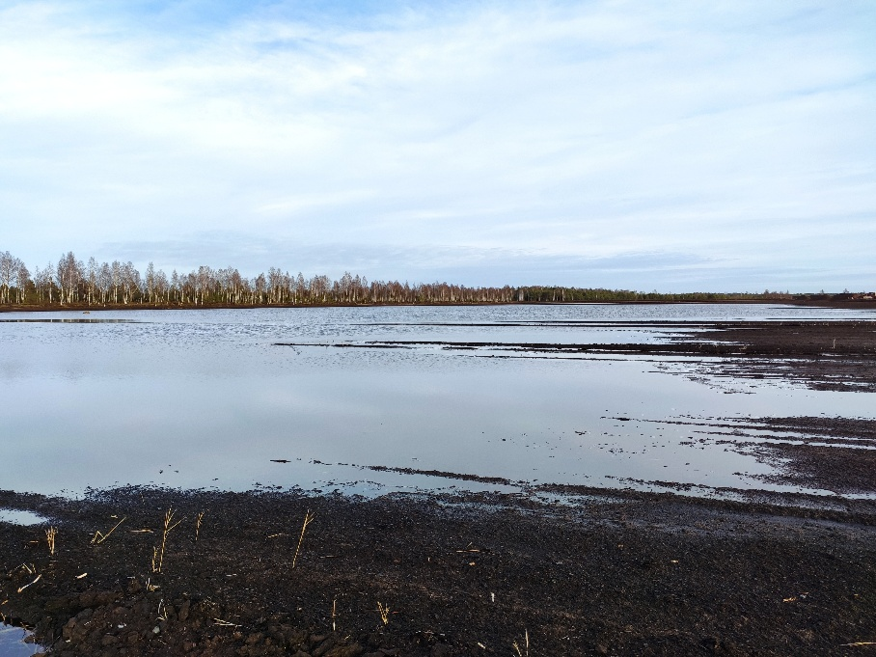

Taustainfo:
Rahvusvaheline vaade kriisi käsitlemiseks
EU - Farm to fork ohus ehk tarbijate toidulaua mitmekesisus ja selle hind
EU info laiemalt (Hollandi eesti ja inglise keelne kiri):
Historically low availability: Raw material shortages put West European substrate market under pressure (https://www.hortidaily.com/article/9755048/raw-material-shortages-put-west-european-substrate-market-under-pressure/?utm_source=chatgpt.com)

Supplies of key raw materials such as peat and coir for the West European substrate market have dropped to historically low levels. The main reasons- Persistent bad weather in peat- and coir-producing regions, combined with rapidly growing global demand, especially from Asia, which leaves less product available for West Europe.

According to the Dutch Association of Potting Soil and Substrate Producers (VPN), these developments will create serious challenges for the Dutch substrate industry in the coming year.

Peat production lagging far behind:

Heavy rainfall in the Baltic States, Finland, and Sweden between May and July 2025 has severely limited peat harvesting. This year's harvest is expected to reach only 40–50% of normal volumes. White peat (sphagnum peat moss) is facing the biggest shortfall, with harvest levels at just 25–35% of normal.

For Dutch substrate companies, the Baltic States, Finland, and Sweden are the most important peat suppliers. Harvesting must take place during the dry summer months, as peat cannot be extracted in wet conditions. Peat remains the backbone of Dutch substrate production, accounting for about 4 million cubic meters per year out of a total annual production of 7.5 million cubic meters.

Coir: Second most used raw material
Coir is the runner-up, with an annual volume of around 1.1 million cubic meters in the Dutch substrate industry. Here too, unpredictable rainy seasons in producing regions are creating supply challenges and affecting availability.

Other raw materials under pressure
Demand for renewable raw materials such as bark, wood fiber, and compost is also on the rise. While new renewable sources like cultivated plant fibers show promise, the available volumes of consistent quality are still limited, and they cannot yet replace peat at scale.

The 2022 industry agreement, Covenant on the Environmental Impact of Potting Soil and Substrates, brings together 15 partners in the Dutch substrate sector. Its goal is to reduce environmental impact by increasing the use of locally sourced renewable materials and responsibly harvested peat (RPP-certified). These targets remain a priority, especially as alternative raw materials become an increasingly important part of the supply chain.

Global demand for substrate raw materials rapidly increasing
With the world's population still growing, the demand for food will keep rising. Urbanization adds another layer, as green, livable cities become a greater priority. Substrates play a vital role in both sustainable food production and urban greening.

Wageningen University research previously predicted that global substrate demand in 2050 could be 400% higher than in 2020. The trend is already visible: in just five years, China's covered horticulture area has expanded from 700,000 to 3 million hectares. This surge in demand from China is already impacting global raw material availability.

In a world marked by geopolitical uncertainty the Dutch and European horticulture and substrate sectors will need to rethink their strategic position on raw material sourcing.

What does this mean for 2026?
Right now, raw material markets are under intense pressure and remain partly unpredictable. Some products are hard to obtain, unavailable altogether, or only offered at steep prices. There is still a chance of catching up slightly on peat harvesting before the end of August, but the backlog cannot be fully recovered.

This makes it difficult to give a detailed forecast for 2026. The VPN plans to issue a more comprehensive update at the end of August or early September, outlining developments in the raw materials market and their impact on substrate production.

The VPN's main advice to potting soil and substrate buyers: talk to your suppliers early. In their words, "Only through timely coordination can we ensure that the quantity and quality of products are safeguarded as much as possible."

At the North American trade show Cultivate, the pressure on the substrate market was already a topic of discussion.

